CSD340 Module 1, Assignment 1.3
Building a Web Page Exercise, Part 1
Student: Zach White
Professor: Sue Sampson
Date: June 6, 2026
Class: CSD340

Assignment Overview
In this assignment, I created a basic HTML page from starter code, validated it using the W3C HTML Validator, corrected errors, added required content including an h1 heading and a weather sentence, and confirmed the final page renders correctly in a browser. All steps are documented below with screenshots.

Step 1: Create Directory & HTML File
Assignment Instruction
Create a new directory under your local csd-340 folder and name it module-1. Create a new HTML document in a text editor named White_Mod1_3.html and place it in the module-1 directory. Using the starter code provided, create a basic HTML page.
What I Did
I created a new folder called Module 1 inside my local C:\CSD\CSD340 repository. Inside that folder, I created a new file named White_mod1_3.html using VS Code. I then added the starter HTML code provided in the assignment which intentionally contained errors as the starting point before validation.

Step 2: First W3C Validation Errors Found
Assignment Instruction
Visit the W3C website and validate your markup using the HTML Validator. Select 'Validate by Direct Input', paste your code, and take a screenshot showing the errors.
What I Did
I went to validator.w3.org and selected 'Validate by Direct Input'. I pasted the original starter code which was missing a title value and contained a typo ('</thml>' instead of '</html>') and clicked Check. The validator returned 3 errors: (1) the title element must not be empty, (2) a stray end tag 'thml' was found after the body had been closed, and (3) a stray end tag 'thml'. These confirmed the code needed to be corrected before it could be a valid HTML document.
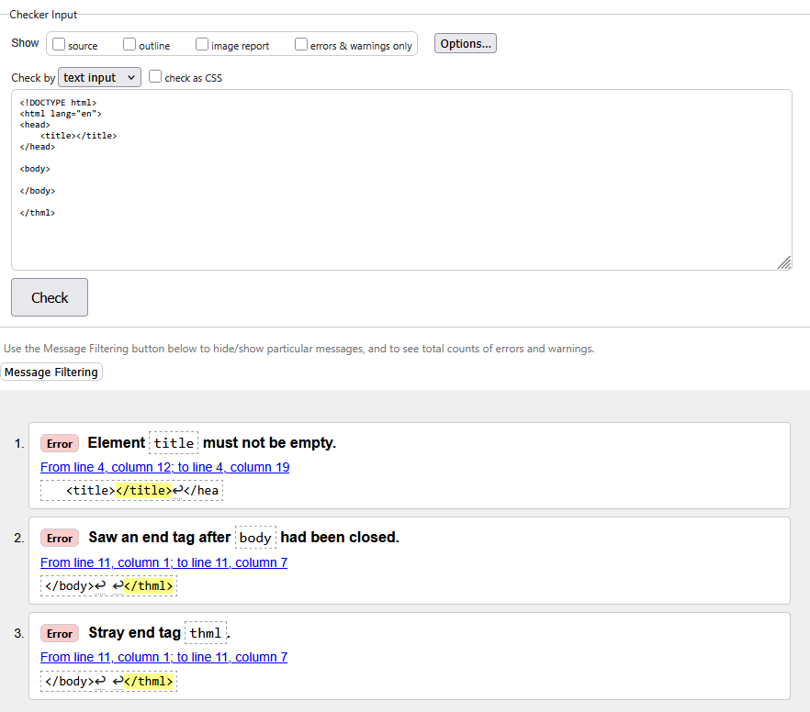

Step 3: Errors Corrected Re-Validated (0 Errors)
Assignment Instruction
Correct the identified errors, re-validate the HTML code using 'Validate by Direct Input', and take a screenshot of the updated results showing 0 errors.
What I Did
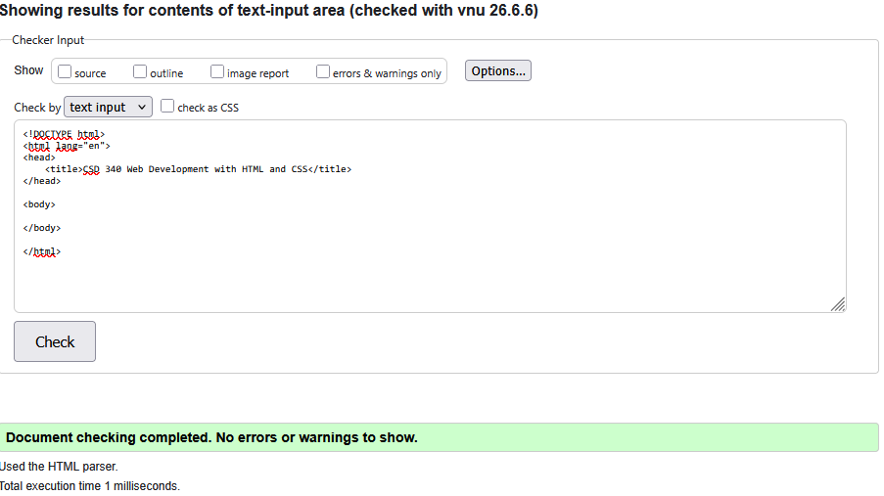
I fixed the three validation errors: I added the title text 'CSD 340 Web Development with HTML and CSS' to fill the empty <title> element and corrected the closing tag typo from </thml> to </html>. I re-pasted the updated code into the W3C validator, and it returned a green confirmation: 'Document checking completed. No errors or warnings to show.' confirming the HTML structure was now valid.

Step 4: Content Added & Final Validation 0 Errors
Assignment Instruction
Add a single h1 element with the text 'Assignment 1.3 Building a Web Page Exercise, Part 1'. Add a sentence below it about your location and today's weather (using the degree symbol). Update the document title. Re-validate and screenshot the 0-error result.
What I Did
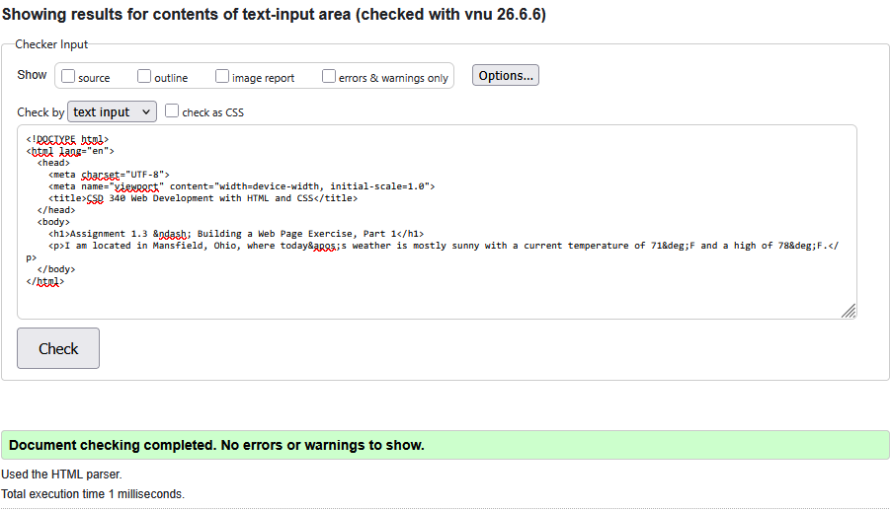
I added an <h1> element with the required title text, using the HTML entity &ndash; for the dash. Beneath it I added a <p> tag with a weather sentence: 'I am located in Mansfield, Ohio, where today’s weather is mostly sunny with a current temperature of 71°F and a high of 78°F.' using &deg; for the degree symbol and &apos; for the apostrophe. I also added <meta charset="UTF-8"> and a viewport meta tag for best practices. After re-pasting the full code into the W3C validator, it again returned 0 errors and 0 warnings, confirming the fully built page is valid HTML.

Step 5: Page Rendered in Browser
Assignment Instruction
Open the HTML file in your computer's default browser and take a screenshot of the rendered web page.
What I Did
I opened White_mod1_3.html directly in Chrome by double-clicking the file in my local Module 1 folder (file:///C:/CSD/CSD340/Module%201/White_mod1_3.html). The page rendered correctly showing the bold h1 heading 'Assignment 1.3 Building a Web Page Exercise, Part 1' and the weather paragraph below it. The browser tab also correctly displayed the updated title 'CSD 340 Web Development with HTML and CSS', confirming all elements were properly applied.
